Abdul Akher Monjur Khondoker
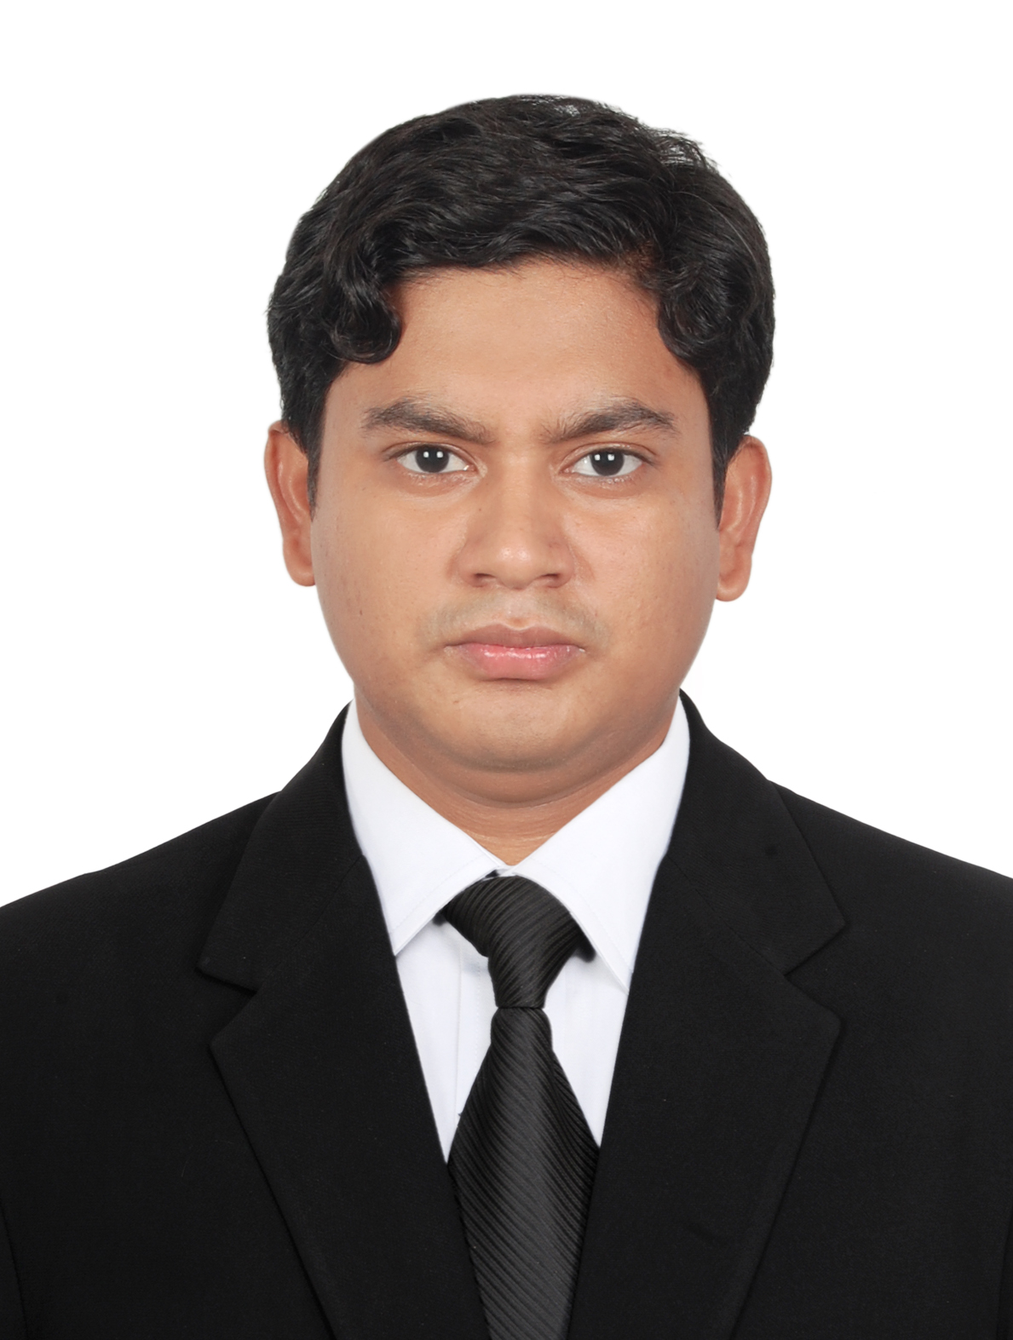
H-17, South Banasree,
Banasree, Rampura, Dhaka-1219, Bangladesh.
Mobile: 01518371071, 01728890130
Email: monjurhasan.hasan@gmail.com

PERSONAL PROFILE:

Want to build-up my career such in Challenging industry where there is a scope to prove one’s ability, performance, and efforts, and where there is a scope to learn, grow, and achieve a significant position in the higher echelon by showing one’s own performance sincerely.

EDUCATIONAL QUALIFICATION:

Masters

Institution : Abu Jor Gifari College, Dhaka.
Sub : Political Science
Result : 3.22 (out of 4)
Year of passing : 2015

Bachelor of Arts (BA.Honrs)

Institution : Kabi Nazrul Govt, College, Dhaka.
Sub : Political; Science
Result : CGPA 3.12 (out of 4)
Year of passing : 2014

Higher Secondary Certificate (HSC)

Institution : Feni Govt. College
Board : Comilla
Group : Science
Result : CGPA 3.20( out of 5)
Year of passing : 2009

Secondary School Certificate (SSC)

Institution : Alkara Hafijul Islam Chowdhury High School
Board : Comilla
Group : Science
Result : CGPA 4.38( out of 5)
Year of passing : 2007

EXPERIENCES:

- 3 years teaching experience as an Assistant Teacher in “KACHIKANTHA PREPARATORY SCHOOL” from 2012 to 2015
- 2 years working experience as an Accountant in “ASBD Systems & Network” from 2016 to 2018.
- 1 year working experience as a Program Manager in “New Track Consultancy Firm” from 2018 to till now.

LANGUAGE PROFICIENCY:

Language | Reading | Writing | Speaking | Listening
Bengali | Excellent | Excellent | Excellent | Excellent
English | Excellent | Excellent | Good | Good

KEY COMPETENCIES:

- Energetic and promising
- Punctual and well-presented
- Confident outlook
- Good listener
- Adaptable to work in new situation
- Able to work individually and within team
- Open minded and non-judgmental
- Enjoy competitive environment
- High energy level
- Able to work under pressure
- Attention to detail
- Problem solving

COMPUTER LITERACY:

MS Word, MS Excel, MS Power point, surfing and browsing, Fl studio (Musical soft) Adobe Photoshop etc.

INTEREST:

Playing Guitar, Keyboard, Cricket, Travelling, Hangout, Comedy Movie, Photo Shoot, video Games and do entertain many more which make me happy, also others.

PERSONAL INFORMATION:

Father’s Name : Abdul Maleque Khondoker
Father’s Occupation : Business
Mother’s Name : Fatema Begum
Mother’s Occupation : Housewife
Permanent Address : Vill: Narankuri, P.O: Alkara, P.S: Chouddagram, Dist: Comilla
Date of Birth : 9th September, 1992.
Nationality : Bangladeshi by Birth
Marital Status : Unmarried
Religion : Muslim

Reference:

- Aminul Hoque
Senior Assistant Relationship Officer
Bank Asia LTd. , Principal Office Branch
Email : aminulhoquebablu@gmail.com
Mobile : 01683438850

- Roksana Akter Banu
Head of the department of Political Science
Abu Jor Gifari College, Dhaka.
Mobile : 01817070641

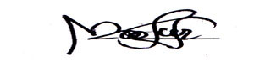
Abdul Akher Monjur Khondoker
…………………
Signature

